DATE 02-07-2025
Questions:
- From datafile find the name age and department of all employees whose name starts with ‘s’ and ends with ‘a’. Example:- awk '/^J/{ print $0 }' datafile
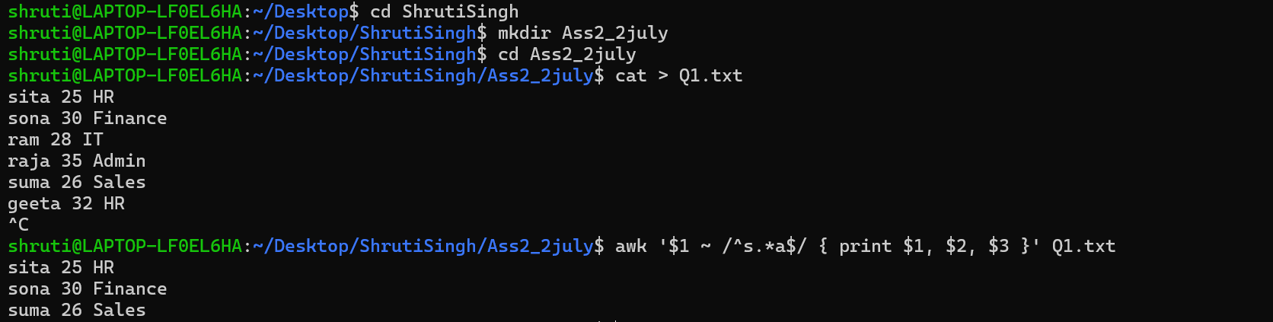
- Print all records where the record ends with n.
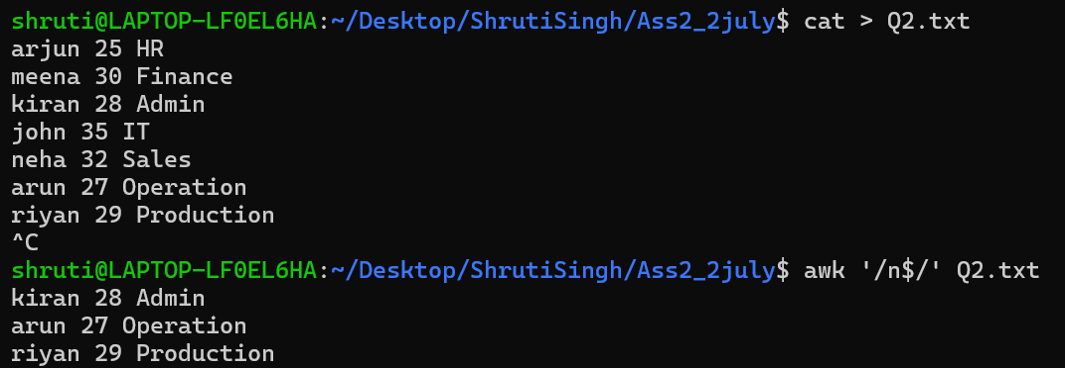
- Print all records that start with J and ends with n.
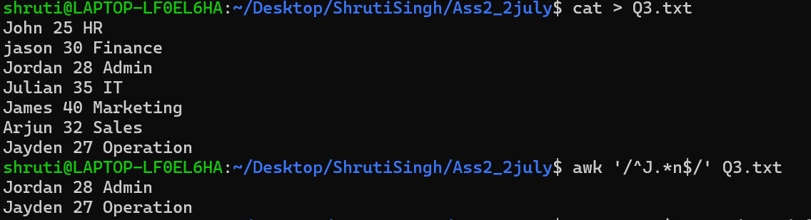
- from ifconfig output find all IP addresses.
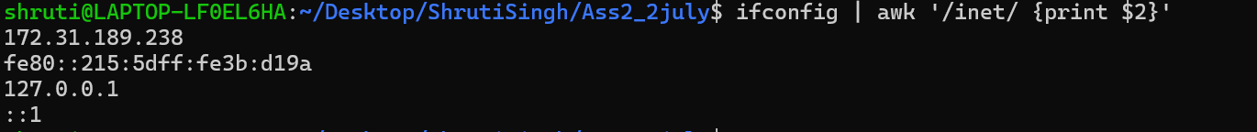
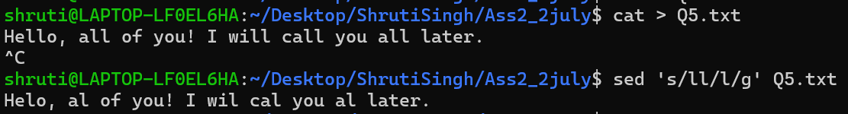
- Replace all occurrences of 'll' with a single 'l'.
- Replace a word that starts with H.
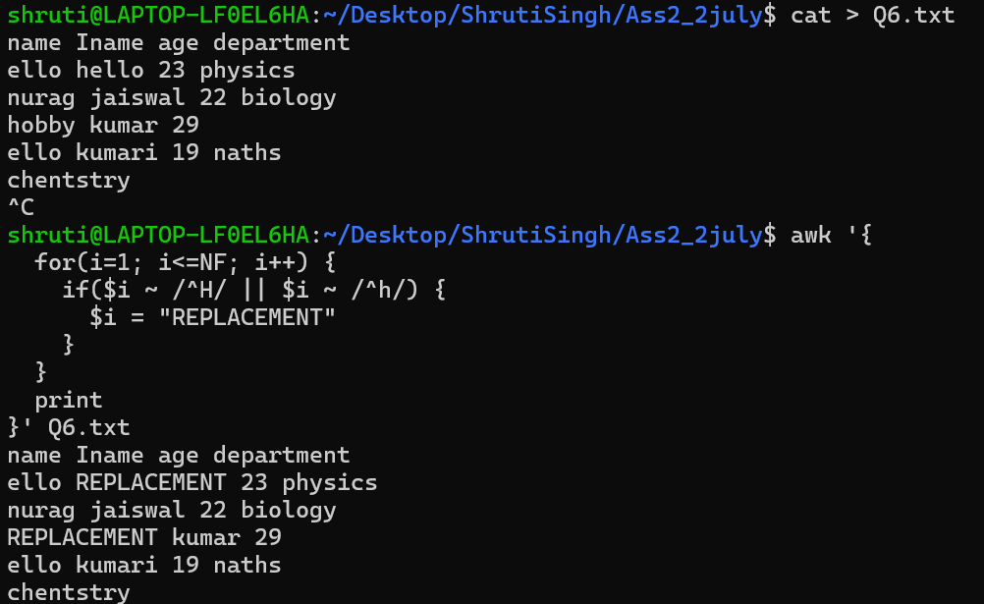
- From the text TestT100String only extract the digits.
- Write a Bash script to find the latest file in any given folder. The folder should be presented as a command line argument. Make a copy of the file and find the most occurring word in the file.
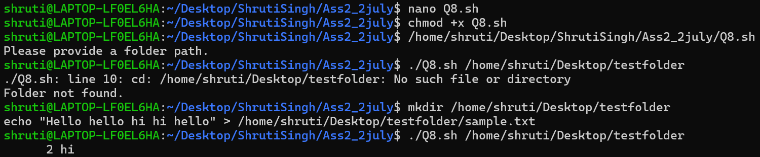
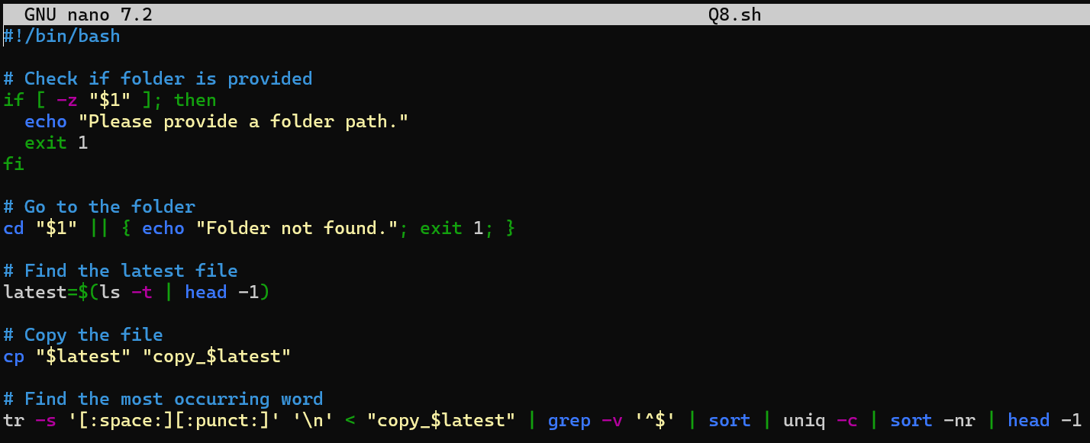
- Write a Bash script to print the name of the the person who last logged into the system. From the home folder find out (if any) files for which this person is the owner. Can you find the total login time of this user
- Write a Bash script to use find command to find the path of conf.d file. From the path replace all “/” symbols and replace them with “-” and print the path.
Others:
1. User Login Tracker
Write a script to read the /var/log/auth.log file and extract the list of successful SSH login attempts using grep, awk, or cut. Display the unique usernames and their login timestamps.
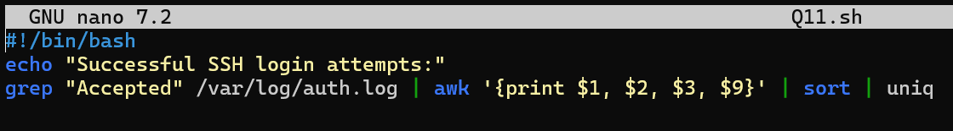
2. System Inventory Report
Create a script that gathers and displays system information: hostname, IP address, CPU model, total memory, and disk usage. Use commands like uname, hostname, ifconfig, free, and df.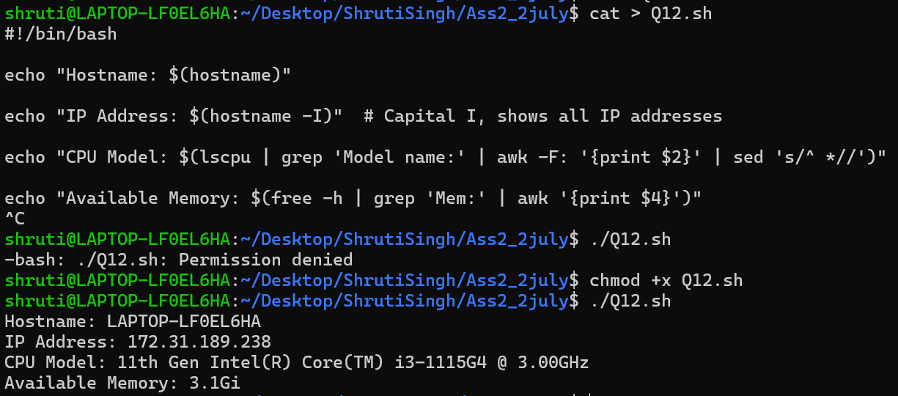
3. Check Disk Usage & Alert
Write a script that checks the disk usage of root (/) partition. If the usage exceeds 80%, print an alert. Use df, awk, and if conditionals.
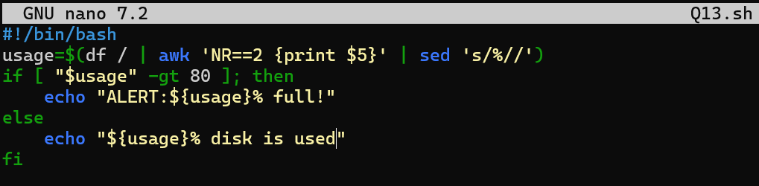
4. User Home Directory Checker
Loop through all users in /etc/passwd, extract their usernames and home directories using cut, and print whether the directory exists or not using an if check.
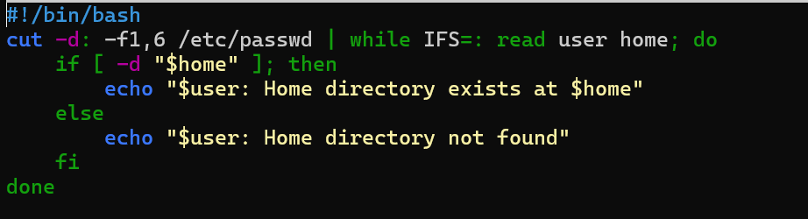
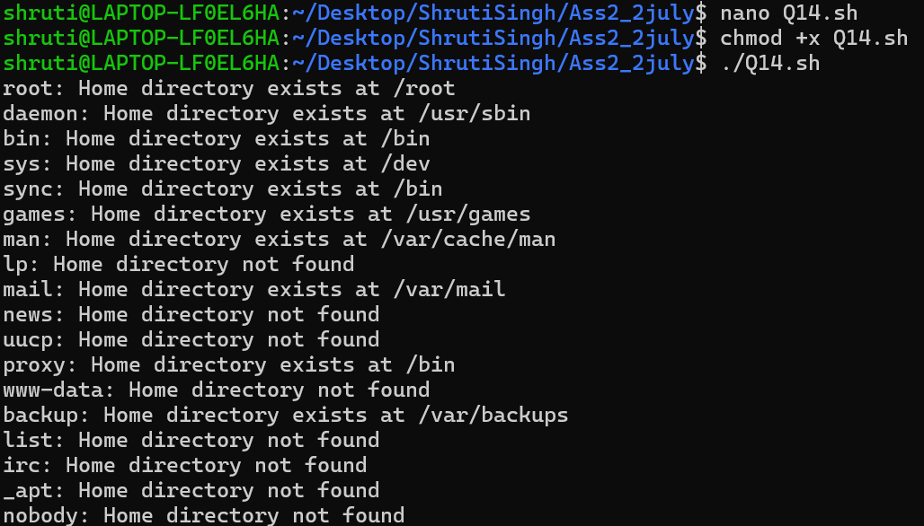
5. Parse and Filter Logs
Using grep and awk, write a script to parse a given log file and list all lines containing the word “ERROR” along with the line number.
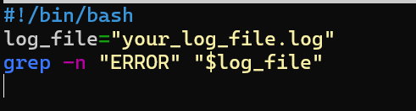
6. Service Status Checker
Create a script that takes a list of service names and checks whether each service is active or inactive using systemctl or service. Use loops and if statements.
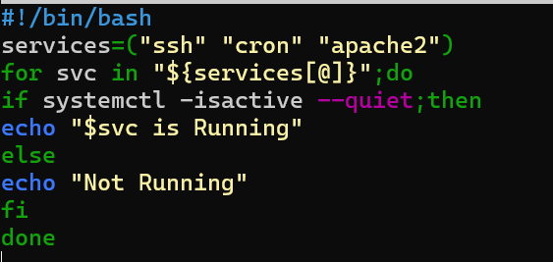
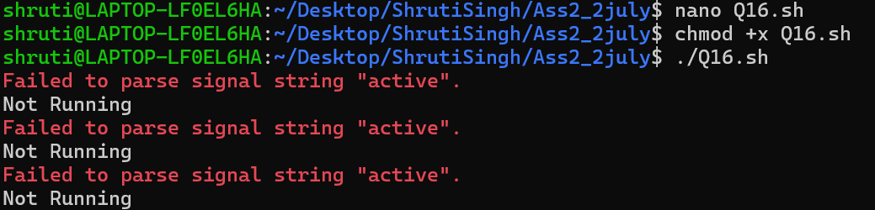
7. CSV Data Cleaner
Given a CSV file with extra spaces and inconsistent delimiters, use awk, sed, and cut to clean it and print only selected columns neatly.
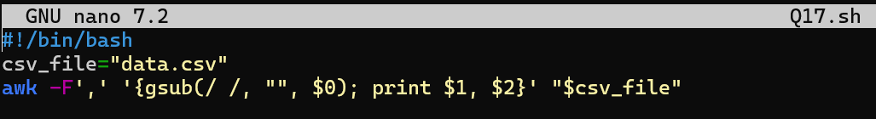
8. Password Strength Validator
Accept a string as input and use a combination of regex (grep or [[ ... =~ ]]) to validate that it’s at least 8 characters, contains one number, and one special character.
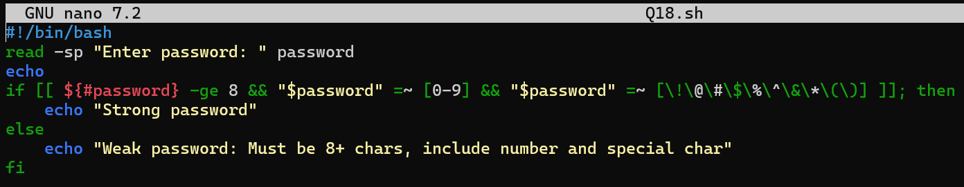
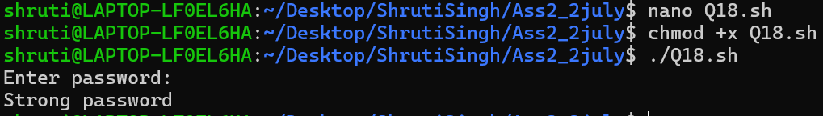
9. Process Monitor
Create a script that accepts a process name as input, checks if it is running using ps and grep, and displays its PID and memory usage. 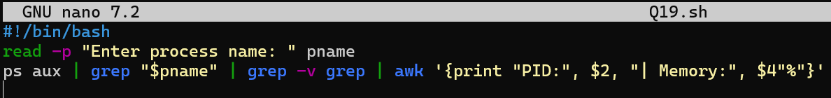
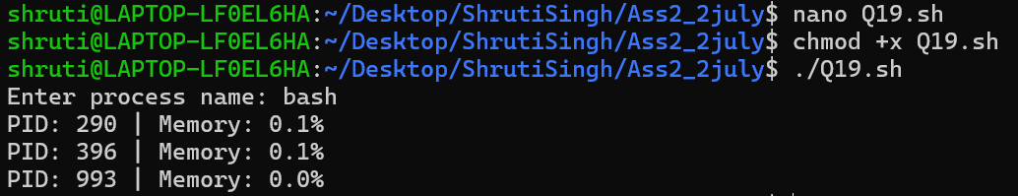
10. Scheduled Cleanup
Write a script that deletes .log files older than 7 days from a given directory. Use find, conditionals, and optionally log what files were removed
